**Name: __Blake Raphael**

**Processing Project: Picture Grid Drawing**

[UTeach CS Principles](http://uteachcs.org/)

In this assignment you will use *Processing 3* to create a point-by-point approximation of an image. **TURN IN THIS DOCUMENT IN YOUR U DRIVE FOLDER.**

* Open the *Processing 3* sketch/application named ***PictureGridDrawingActivity*** in your U drive folder. Click on the Play button to run the sketch/app.
* Click Upload Picture, and choose an image or logo to load into the program window. Next you will “digitize” this image by redrawing it along a grid.
  + **IMPORTANT:** Select a relatively small and simple image or logo to upload. The better job you do in creating a digital approximation, the more points you’ll receive.
* Select Toggle Grid, and with the grid on, click carefully on grid intersections in order to place points. Place points around your image in order to represent it as best you can. To remove an unwanted point, click it again.
* The Toggle Line function will cause the next series of points placed to be directly connected with lines. **Note:** Clicking dots will toggle them on and off (as a sort of “UNDO” feature). This means that there can only be one line leaving and entering each dot.
* Create a point-by-point representation of your image simply by creating the points that define/outline its major features.
* Toggle both the grid and the image so that they are not shown.
* Try it with a new grid size. Adjust the granularity of the grid with the +|- buttons. Attempt the drawing/guessing activity once again with the new grid.

**TURN-IN DELIVERABLES:**

1. Paste your original image here:

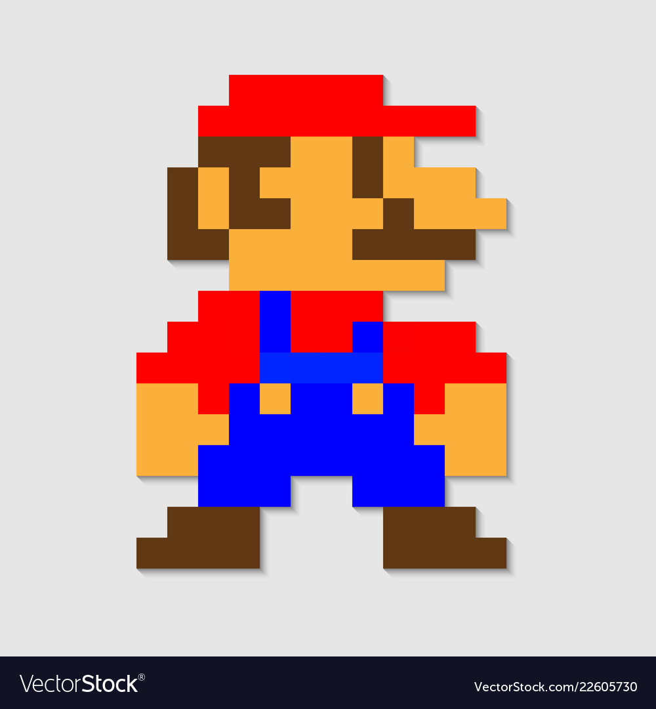

1. Decide which approximation you will turn in – either the one using the standard grid size or the modified grid size. Use the *Snipping Tool* to copy and paste your best approximation here:

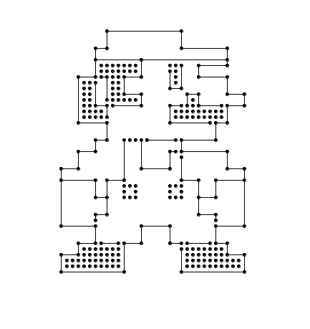

1. TWO PARTS:

a. How well does your representation above approximate the original? Choose a value 1 – 10, where 1 represents a very poor representation and 10 represents an excellent representation. **BE HONEST.**

**Poor**  **Average**  **Excellent**

1 2 3 4 5 6 7 8 9 ***10***

b. *Why* is your approximation poor, average, or excellent?

My approximation is excellent because the approximation is very clearly the same image as the original. The image I chose had rigid lines with 90 degree angles giving a good image to try and approximate with.

1. How is using a grid a form of discretizing the image?

The grid gives specific start and stop points of each part of the image. Each space between dots/ lines is the exact same, allowing a great discretion of the approximation.

1. How did adjusting the grid size affect the outcome?

Adjusting grid size gives either a finer or less detailed approximation. Changing the grid size to match the image lines will provide a better approximation. If the image doesn’t have rigid lines or 90 degree angles, the smaller grid will give the best approximation

1. TWO PARTS:
   1. What are the limitations of the ***PictureGridDrawingActivity*** application?

There is only so small the grid can get to approximate, making softer shapes and circles difficult to approximate

* 1. What features would make ***PictureGridDrawingActivity*** able to create *better* approximations?

An easier to use line tool, smaller grid, allowing drag and drop of the dots

1. Look at the source code for ***PictureGridDrawingActivity*** in *Processing 3*. How would you change the code so when the user clicks the Toggle Grid button, the button turns red instead of yellow? Be sure to test your code!

|  |  |
| --- | --- |
| **Line Number** | **Modified Code** |
| 54 | fill(#ff0000); |